DATA FLOW DIAGRAM
Team ID
Project Name | Subscription waste Detector
Date | 21/07/2026
Maximum Marks | 4

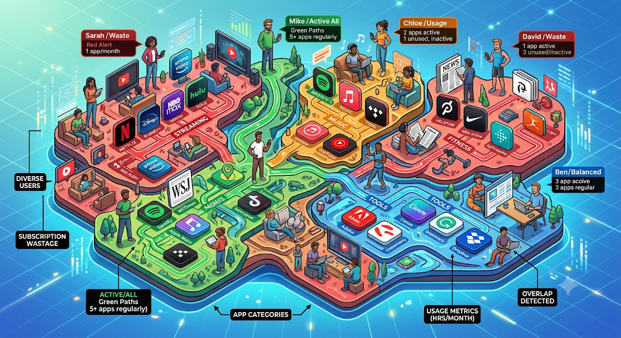

This is the picture describing the usage of various subscription apps by various persons.
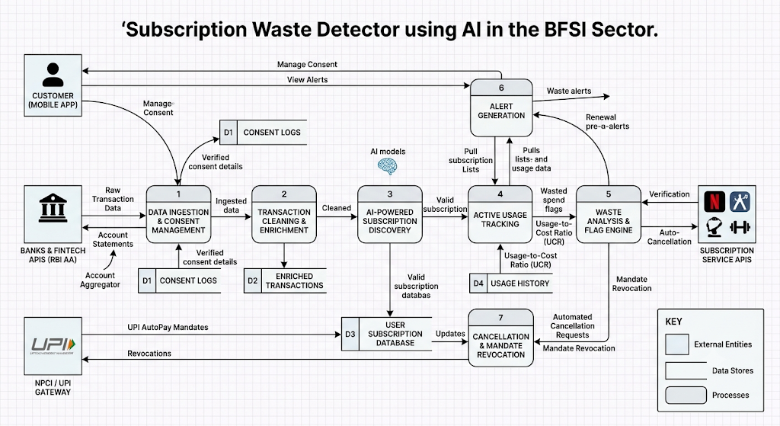

DATA FLOW DIAGRAM

